Chris Badalucco

Two Things LLC. | 2 first street, Albany ny 12203

Project Advisor: Professor John Avitabile degree advisor: dr. ian macdonald

Software Design

Jalopy Exchange Project

Table of Contents

1 Software Process Model 1

2 Development Tools and Techniques 1

2.1 Technologies 1

2.2 System Requirements 2

3 Development Schedule 3

3.1 Gantt Chart 3

3.2 Testing 4

3.3 Training 4

# Software Process Model

This project followed an agile development methodology. Since the developer had to start development prior to knowing the full scope of the project, it was required that the developer be very flexible and able to respond to change quickly. The project team was very small so it was easy to convey information

# Development Tools and Techniques

## Technologies

* **Groovy** - http://groovy.codehaus.org/
  + an agile and dynamic language for the Java Virtual Machine
  + builds upon the strengths of Java but has additional features inspired by languages like Python and Ruby
* **Grails** – http://grails.org
  + an open source, full stack, web application framework for the Java Virtual Machine
  + convention over configuration development experience
  + Grails Object Relational Mapping (GORM) - http://grails.org/doc/latest/guide/GORM.html
    - runs on top of Hibernate 4 - http://hibernate.org/orm/
  + Tomcat web container
* **H2 Database Engine** – http://h2database.com
  + an open source relational database management system written in Java
  + can be embedded in Java applications (an in-memory database solution) or in client-server mode
* **ExtJS** - http://www.sencha.com/products/extjs
  + javascript framework for designing user interfaces
  + supported by all major browsers
* **Git Version Control** - https://github.com/badastrose/JalopyExchange
  + a free version control for open source projects hosted by GitHub

## System Requirements

The system requires Grails version 2.4.3 or later and Groovy 2.3.6 or later. Grails has the Tomcat web container and H2 data source embedded within itself.

GRAILS COMMAND LINE SCRIPTS:

“grails run-app” – Grails will launch the embedded Tomcat server and load the web application directly from the development sources. *This method was used for the development of this project*

“grails run-war” – similar to the previous option but Tomcat runs against a built WAR rather than the source.

# Development Schedule

## Gantt chart

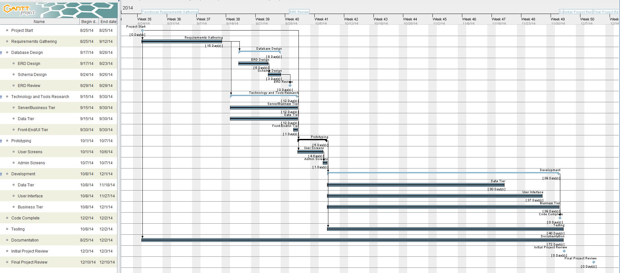

## Testing

Please refer to the *Testing Results* document.

## Training

An online video User Guide can be found at http://youtu.be/kxj4w4sIP2Q

Administrator features begin at 11:00 minutes - http://youtu.be/kxj4w4sIP2Q?t=11m